DBMS MINI-PROJECT REPORT

STUDENT ACADEMIC RECORD MANAGEMENT SYSTEM

1. Overview
The Student Academic Record Management System is a database-driven application designed to organize student information in one place. It keeps academic history, semester-wise performance, subject marks, study gaps, seminar participation, and extracurricular activities in structured records. A web interface allows an administrator to find and maintain information without handling separate files. The system uses SQLite for persistent storage and can export selected records to Google Sheets when the required API settings are available.

2. Project Goals
Create a single, organized repository for student information.
Record previous education details, including SSC, HSC, and diploma information where applicable.
Maintain semester results and individual subject marks.
Document academic interruptions or drop years.
Keep a history of seminars and co-curricular or extracurricular participation.
Provide search facilities using a student name or roll number.
Present academic performance through tables and graphs where implemented.
Allow records to be exported to Google Sheets after integration is configured.

3. Requirements
Hardware: A desktop or laptop with at least 4 GB RAM. An internet connection is needed for online spreadsheet export.
Software: Windows, Linux, or macOS; Node.js 18 or later; npm; a modern web browser; SQLite; and Google Sheets API credentials for the optional export feature.

4. Application Structure
The application follows a web-based client/server arrangement. HTML, CSS, and JavaScript form the user interface. The server side runs on Node.js with Express and processes requests from the browser. SQLite stores the application records, while the Google Sheets API is an optional external service used to export data.
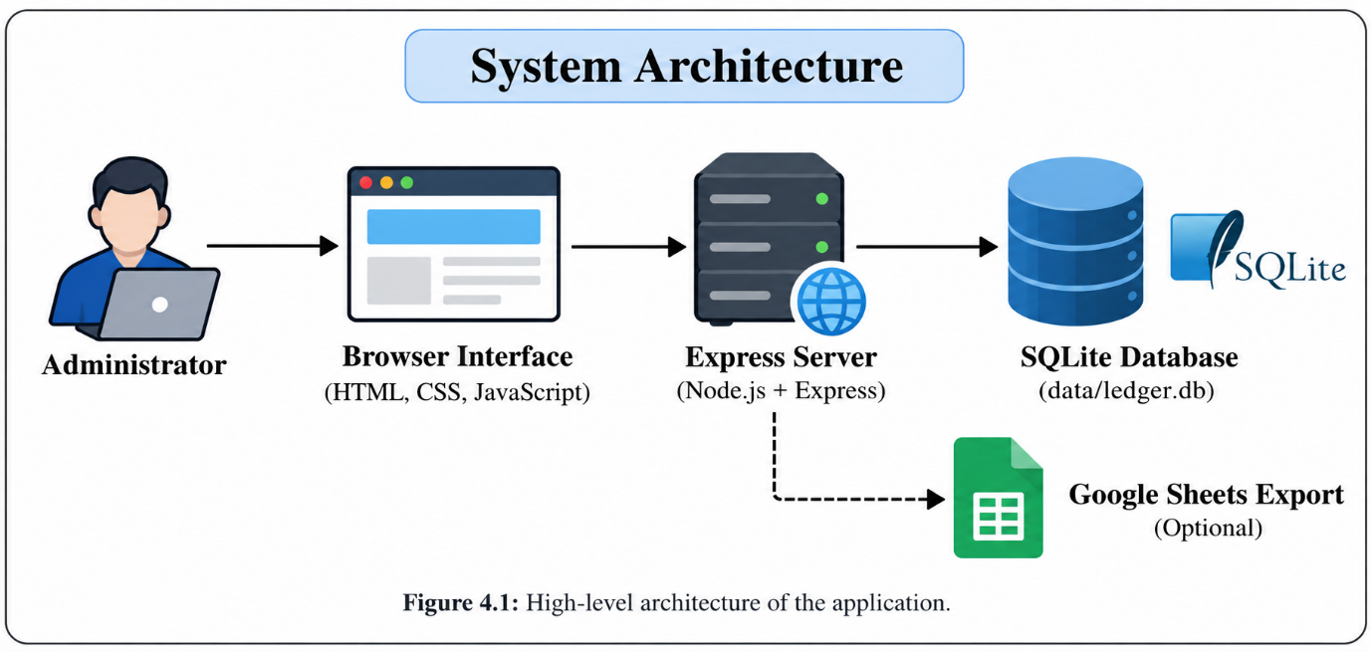Figure 4.1: High-level architecture of the application.

5. Database Design
SQLite is used as the primary data store. The database is organized around student details and related records for education history, semester results, subject marks, academic gaps, seminars, and activities. This arrangement separates different kinds of information and allows related records to be retrieved together.

5.1 Keys and Relationships
A primary key identifies each row uniquely. Foreign keys associate dependent records with the relevant student or semester record, helping preserve relationships between tables.

5.2 Integrity Rules
Depending on the table definition, constraints such as PRIMARY KEY, FOREIGN KEY, UNIQUE, CHECK, ON DELETE CASCADE, and ON DELETE SET NULL can be used to prevent invalid values and define how related records behave when data is deleted.

5.3 Normalization
Normalization helps limit duplicate data and update anomalies. First Normal Form (1NF) requires atomic values; Second Normal Form (2NF) removes partial dependencies on a composite key; and Third Normal Form (3NF) removes transitive dependencies. The final normal-form status must be confirmed against the actual SQL schema.

5.4 Storage Implementation
The Node.js application accesses SQLite through sql.js, a WebAssembly SQLite engine. For a new installation, the database structure is loaded from schema.sql and the default database location is data/ledger.db. Each database write is exported to disk by the application.

6. Main Interface Screens

6.1 Login Screen
The login screen provides the entry point for authorized local use.
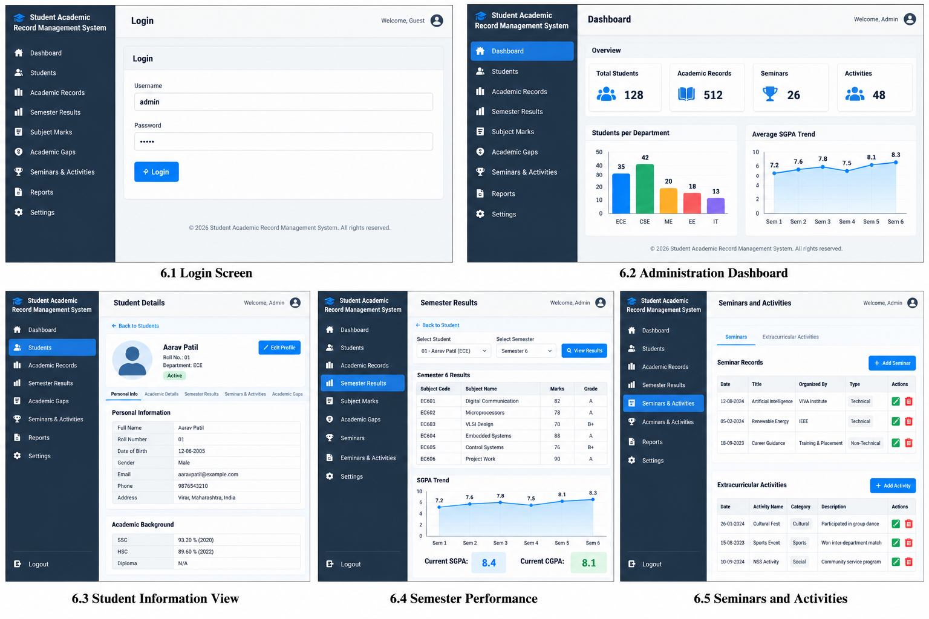

6.2 Administration Dashboard
The dashboard gives access to student records and available management options.

6.3 Student Information View
This view presents a student’s profile and educational background. Add a screenshot.

6.4 Semester Performance
Semester-wise results and subject marks can be reviewed here; include a performance graph if it is available in the implementation.

6.5 Seminars and Activities
This section records participation in seminars and other activities.

7. Testing and Observations
The automated database checks were run with npm test. They verify schema initialization, parameterized reads and writes, unique roll numbers, and student deletion cascading. Interactive browser workflows and Google Sheets export were not exercised in this test run.
Test | Expected behaviour | Observed result
Database initialization and schema | All six documented tables are available. | Passed: all six tables were found after fresh initialization.
Parameterized student write and read | Values are safely stored and retrieved. | Passed: the test preserved the name O'Connor.
Unique roll number | Duplicate roll numbers are rejected. | Passed: SQLite rejected the duplicate value.
Delete student with related record | Related records are removed by the configured cascade. | Passed: the academic gap was removed when its student was deleted.
Interactive UI and Google Sheets export | The UI workflows work and configured exports complete. | Not covered by the automated suite; Google Sheets export remains deferred.
Result summary: npm test completed with 4 tests passed and 0 failed.

8. Basic User Procedure
Install Node.js version 18 or later.
Open the project directory in a terminal.
Install dependencies using npm install.
Start the server using npm start.
Open http://localhost:3000 in a browser.
Use the locally configured login and available screens to search or manage records.
Use the spreadsheet export option only after Google Sheets credentials and the spreadsheet ID have been configured.
Use only the demonstration credentials documented in the project README for local testing. Replace demonstration authentication with a secure configuration before any public deployment.

9. Google Sheets Export
The project can export data to Google Sheets through the Google Sheets API after configuration. Setup generally requires service-account credentials and the target spreadsheet ID. SQLite remains the primary database. Direct changes made in SQL do not automatically initiate an export, and edits made in the spreadsheet are not imported back into SQLite in the current one-way arrangement.
Figure 9.1: Add a screenshot of a successful spreadsheet export, if available.

10. Constraints and Possible Improvements

Current Constraints
Spreadsheet export depends on correct API configuration.
Database changes do not automatically synchronize with Google Sheets.
Spreadsheet-side edits are not synchronized back to the database.
SGPA is entered manually rather than calculated automatically.
Demonstration login credentials are not appropriate for a public system.

Future Enhancements
Introduce scheduled or event-based export synchronization.
Add carefully validated two-way synchronization if required.
Calculate semester results using the institution’s credit and grading rules.
Strengthen authentication, roles, and access control.
Add downloadable reports, filters, and more detailed visual analytics.

11. Conclusion
The Student Academic Record Management System illustrates how a relational database can support the organized handling of academic and activity information. Its design provides a practical example of tables, keys, relationships, integrity constraints, normalization, and optional integration with an external spreadsheet service. The final report should be updated with screenshots, schema details, and test results from the actual running project.

12. References
SQLite Documentation — https://www.sqlite.org/docs.html
Node.js Documentation — https://nodejs.org/docs/
Express.js — https://expressjs.com/
Google Sheets API — https://developers.google.com/workspace/sheets/api
MDN Web Docs: HTML — https://developer.mozilla.org/en-US/docs/Web/HTML
MDN Web Docs: CSS — https://developer.mozilla.org/en-US/docs/Web/CSS
MDN Web Docs: JavaScript — https://developer.mozilla.org/en-US/docs/Web/JavaScript

